Project 2: Production Planning/Execution DELIVERABLE
With Raw Materials Procurement and Semi-Finished Goods Production

Run MRP (Production Manager)
Explain the plant stock values and relate them to the multi-level BOM and expected stock levels in the preparation homework assignment discussion.
Plant stock values represent the quantities of finish and semi-finished goods and raw materials. And the expected stock levels represent one month of producing bikes.
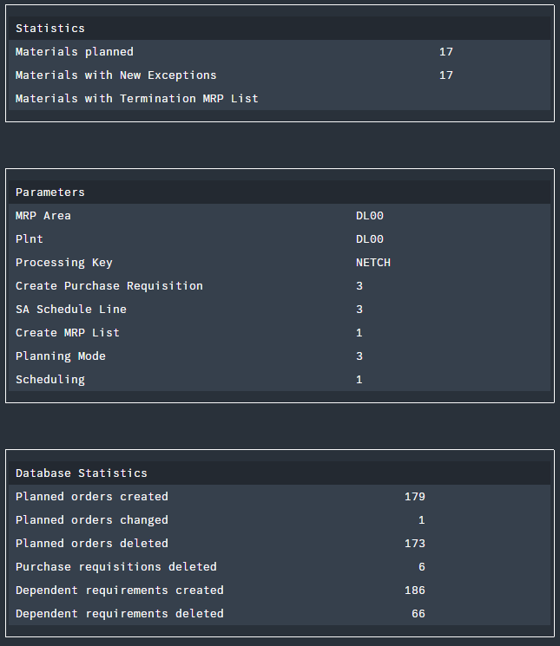
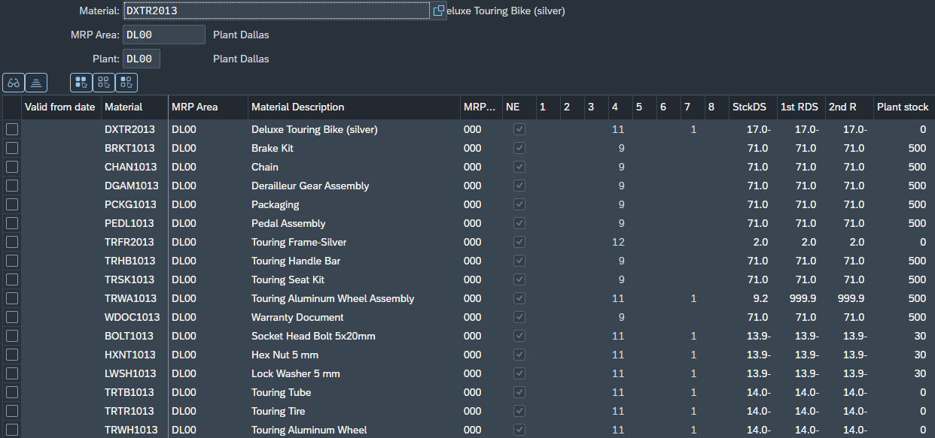

Examine Stock/Requirements Lists (Production Manager)
Why is the January 28, 2025 planned production order for 608 wheel assemblies when the February 1, 2025 planned production of silver Deluxe Touring Bikes is 152?
The wheel assembly planned production is higher because is required to produce both bikes red and silver
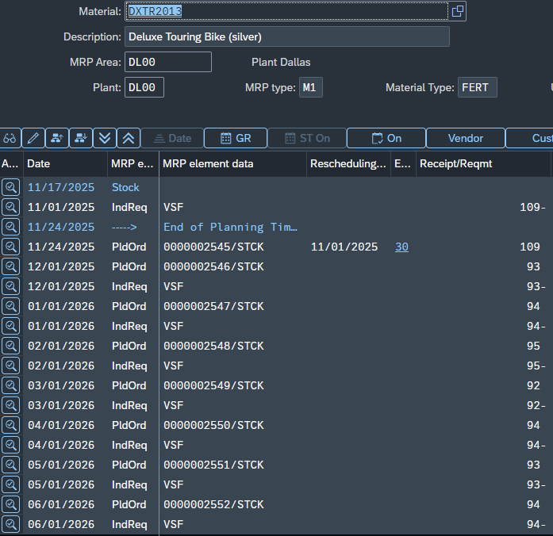
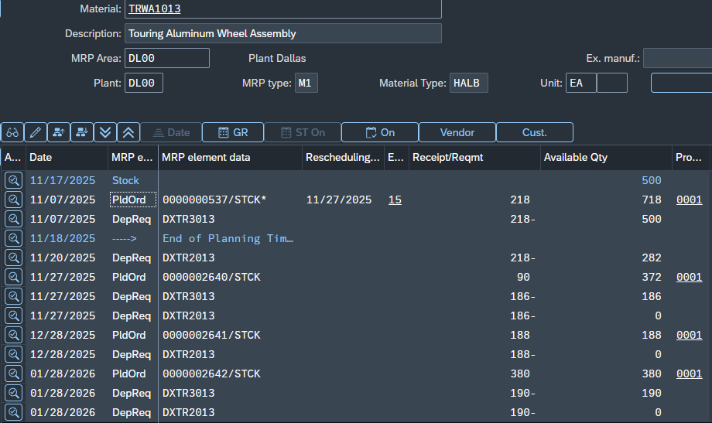

Convert Planned Orders for Raw Materials to Purchase Requisitions (Production Manager)
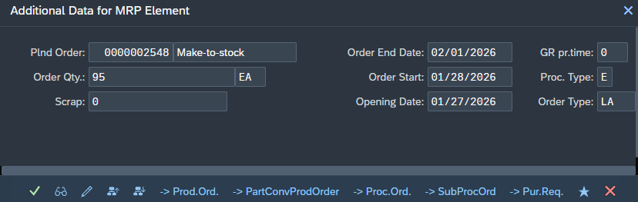
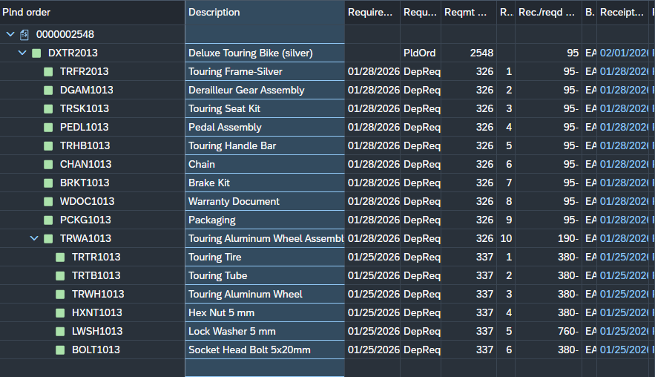

Purchase Requested Raw Materials (Purchasing Agent)
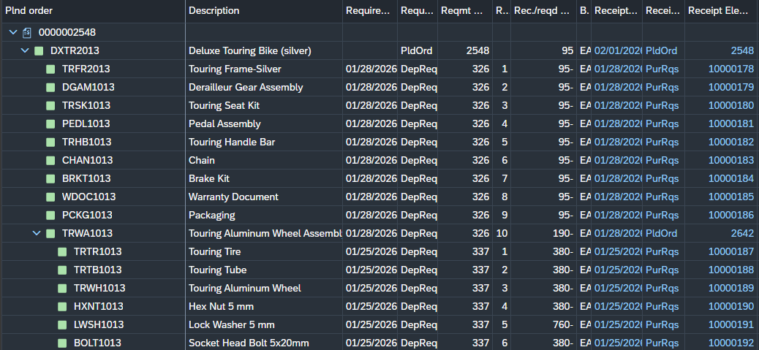

I went back and unchecked ERS and the GR-Bsd IV

Receive Raw Materials (Goods Receipt Clerk)
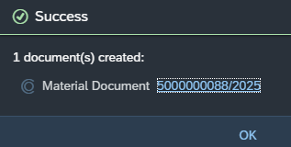


Produce Semi-Finished Goods (Shop Floor Worker)
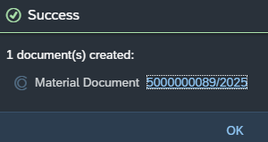

Receive Semi-Finished Goods from Production (Goods Receipt Clerk)
Does the number make sense to you? Explain why or why not.
Yes, the stock report shows the amount of semi-finished goods produced.
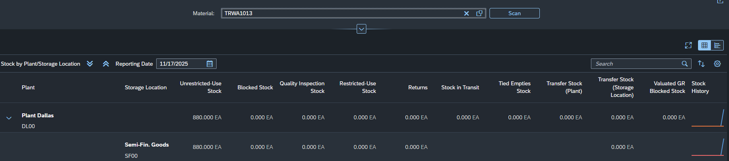

Produce Finished Goods (Shop Floor Worker)
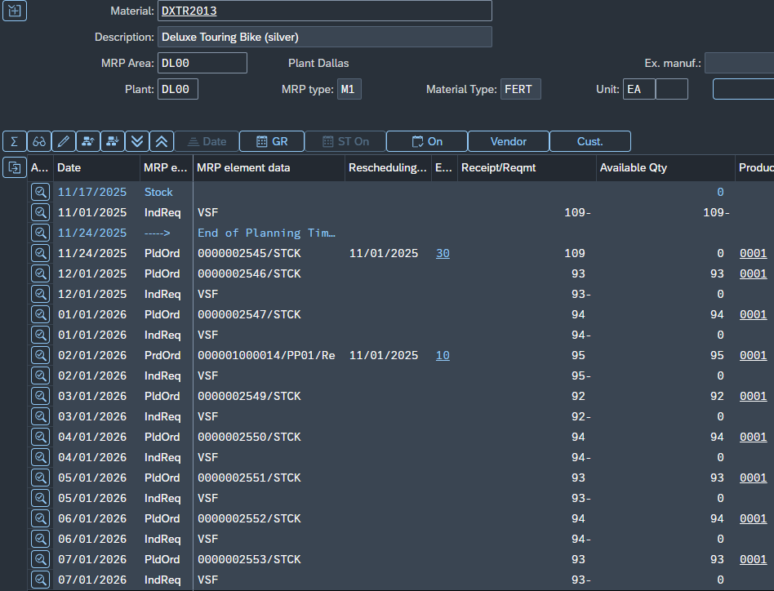

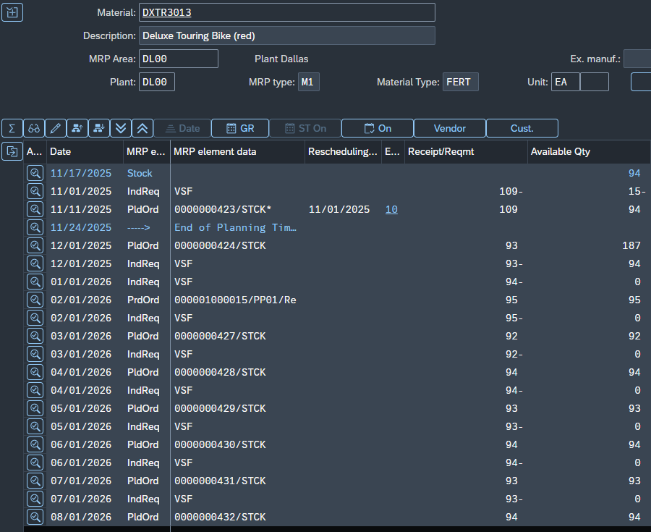


Receive Finished Goods from Production (Goods Receipt Clerk)
Do the numbers in each bike’s stock report make sense to you? Explain why or why not.
Yes, February 2026 planned orders got turn into production order and then production confirmation were completed for both bikes and the stock report shows the number of units produced.
